Real-time/Field-Based Research Project Project
on
E-VOTING THROUGH BLOCKCHAIN
A dissertation submitted to the Jawaharlal Nehru Technological University, Hyderabad in partial fulfillment of the requirement for the award of degree of

BACHELOR OF TECHNOLOGY
IN
COMPUTER SCIENCE AND ENGINEERING
Submitted by
M.AJAY KUMAR (23B81A05K4)
G.ASHWITH (23B81A05L0)
S.S.ABHIRAM (23B81A05N9)


Department of Computer Science and Engineering
CVR COLLEGE OF ENGINEERING
(An UGC Autonomous Institution, Affiliated to JNTUH, Accredited by NBA, and NAAC) Vastunagar, Mangalpalli (V), Ibrahimpatnam (M), Ranga Reddy (Dist.) - 501510, Telangana State,2024-25


CVR COLLEGE OF ENGINEERING
(An UGC Autonomous Institution, Affiliated to JNTUH, Accredited by NBA, and NAAC) Vastunagar, Mangalpalli (V), Ibrahimpatnam (M), Ranga Reddy (Dist.) - 501510, Telangana State.

DEPARTMENT OF COMPUTER SCIENCE AND ENGINEERING

CERTIFICATE

This is to certify that the project work entitled E-VOTING THROUGH BLOCKCHAIN
is being submitted by <M.AJAY KUMAR> (23B81A05K4), <G.ASHWITH> (23B81A05L0) , <S.S.ABHIRAM> (23B81A05N9) in partial fulfillment of the requirement for the award of the degree of Bachelor of Technology in Computer Science and Engineering, during the academic year 2024-2025.

Signature of the Section Coordinator Professor and Head,CSE
(Dr. A. Vani Vathsala)

DECLARATION

I hereby declare that this project report titled E-VOTING THROUGH BLOCKCHAIN submitted to the Department of Computer Science and Engineering, CVR College of Engineering, is a record of original work done by me. The information and data given in the report is authentic to the best of my knowledge. This Real Time/Field-Based Research Project report is not submitted to any other university or institution for the award of any degree or diploma or published at any time before.

M.AJAY KUMAR-23B81A05K4
G.ASHWITH-23B81A05L0
S.S.ABHIRAM-23B81A05N9

Date:
Place:

ACKNOWLEDGEMENT

We extend our sincere gratitude to CVR College of Engineering and the Department of Computer Science and Engineering for providing us with the opportunity and resources to work on this research project.
We express our heartfelt appreciation to our faculty mentors for their guidance, valuable insights, and continuous support throughout the project. Their expertise and encouragement have played a crucial role in shaping our research and development process.
We are also grateful to our peers and the academic community for their constructive feedback and motivation. Their perspectives have helped us refine our ideas and improve the platform.
Finally, we acknowledge the support of our families and friends, whose encouragement has been instrumental in our academic and research journey.
This project has been an enriching learning experience, and we look forward to further developing Research Hive to make a meaningful impact in the research and innovation community.

ABSTRACT
E-voting systems have emerged as a crucial aspect of modern electoral processes, offering the potential for increased convenience, accessibility, and efficiency. However, traditional e-voting systems often face challenges such as security vulnerabilities, voter anonymity, and susceptibility to fraud.
Blockchain technology, with its inherent features of decentralization, transparency, and immutability, presents a promising solution to address these issues. This paper explores the integration of blockchain in e-voting systems to enhance the security, integrity, and transparency of voting processes.
By leveraging the decentralized nature of blockchain, we can ensure that votes are securely recorded, tamper-proof, and verifiable without the need for a centralized authority. Furthermore, the use of smart contracts can automate various aspects of the voting process, including voter authentication and result tallying, while ensuring complete transparency.
This paper also discusses the potential benefits, challenges, and limitations of implementing blockchain-based e-voting systems and proposes a framework for their practical deployment in democratic elections. Through this approach, blockchain has the potential to significantly transform the e-voting landscape, providing a more secure, trustworthy, and efficient means of conducting elections.

TABLES OF CONTENT
 |  |  | Page No.
1 |  | INTRODUCTION
 | 1.1 | Motivation | 8
 | 1.2 | Primary Objectives | 9
 | 1.3 | Problem Statement | 10
 | 1.4 | Project Report Organization | 11
2 |  | LITERATURE REVIEW
 | 2.1 | Existing Work | 12
 | 2.2 | Limitations of Existing Work | 13
3 |  | REQUIREMENT ANALYSIS
 | 3.1 | Software requirements | 16
 | 3.2 | Hardware requirements | 19
 | 3.3 | User requirements | 20
4 |  | SYSTEM DESIGN
 | 4.1 | Proposed System architecture | 24
 | 4.2 | Proposed Methods/ class diagram | 25
5 |  | IMPLEMENTATION
 | 5.1 | Front page Screenshot | 28
 | 5.2 | Results and Discussions | 29
6 |  | CONCLUSIONS
 | 6.1 | Conclusion | 31
 | 6.2 | Future scope | 32
 |  | REFERENCES | 33
 |  | APPENDIX: (If any like Published paper / source code)

1. INTRODUCTION

The advancement of digital technologies has greatly influenced various sectors, including the electoral system. Traditionally, elections have been conducted through manual or electronic methods that involve physical ballots, which can lead to issues such as voter fraud, manipulation, and inefficiency. In recent years, the introduction of e-voting systems has provided an innovative approach to making the voting process more accessible, efficient, and secure. However, despite their advantages, traditional e-voting systems face significant challenges, such as security vulnerabilities, issues of transparency, and a lack of voter anonymity.
Blockchain technology, with its inherent decentralized and immutable nature, presents a promising solution to these issues. By integrating blockchain with e-voting systems, the process can become more secure, transparent, and tamper-proof, while ensuring voter privacy and trust. Blockchain-based e-voting systems promise to revolutionize the way elections are conducted by making them more reliable and resistant to fraud. This paper investigates the potential benefits of blockchain in e-voting systems and explores how its adoption can address the existing challenges in electoral processes.
1.1 Motivation
The motivation for exploring blockchain-based e-voting stems from the persistent challenges faced by traditional and digital voting systems. Traditional paper-based voting is time-consuming, expensive, and prone to human error, while electronic voting systems are often susceptible to hacking, manipulation, and fraud. Additionally, concerns regarding the security of personal data, voter anonymity, and the transparency of election results persist, limiting the full potential of digital democracy.
Blockchain technology, due to its decentralized nature, ensures that data is stored in a distributed manner across a network, preventing central points of failure. It also uses cryptographic techniques to ensure data integrity, making it almost impossible for votes to be altered or tampered with once they are recorded. The transparent and immutable nature of blockchain could help restore voter confidence and prevent election fraud. Given these potential benefits, exploring blockchain for e-voting becomes a compelling solution to these ongoing challenges in the electoral process.
1.2 Primary Objective
The primary objective of this study is to explore the integration of blockchain technology into e-voting systems, focusing on its ability to enhance security, transparency, and efficiency. Specifically, the objectives of this paper are:
- To investigate the potential of blockchain in securing the e-voting process against tampering, fraud, and manipulation.
- To design and propose a framework for a blockchain-based e-voting system that ensures voter anonymity, data integrity, and transparency of the election process.
- To assess the scalability and feasibility of implementing blockchain-based e-voting in real-world scenarios.
- To identify the challenges and limitations of blockchain in the context of electoral systems and propose solutions to overcome them.

1.3 Problem Statement
Despite the numerous advancements in digital voting technologies, traditional e-voting systems still face significant issues, primarily concerning security, voter privacy, data integrity, and transparency. These issues include vulnerabilities to cyberattacks, manipulation of vote results, the centralization of voting infrastructure, and the lack of confidence in the system’s ability to ensure voter anonymity. Many current e-voting systems also suffer from the risk of tampering or altering votes after they are cast, leaving voters and electoral bodies vulnerable to fraud and mistrust.
The primary challenge of traditional e-voting systems is their reliance on centralized databases and processes, which can be compromised. Furthermore, the lack of transparency makes it difficult to independently verify election results, which undermines public trust. Additionally, the complexity and cost of implementing secure systems for large-scale elections, along with the challenge of ensuring compliance with legal and regulatory frameworks, remain significant obstacles.
In light of these issues, blockchain technology presents a promising solution due to its ability to provide secure, transparent, and immutable records. The problem addressed in this study is how blockchain can be effectively applied to overcome the security, privacy, and transparency issues inherent in current e-voting systems, while ensuring scalability and feasibility for real-world election scenarios.

1.4 Project Report Organization
This report is organized into the following chapters:
- Chapter 1: Introduction
This chapter provides an overview of the problem addressed by this study, including the motivation for exploring blockchain in e-voting systems and the primary objectives of the research.
- Chapter 2: Literature Survey
In this chapter, an extensive review of existing literature on traditional e-voting systems and blockchain technology is presented. This chapter explores the evolution of e- voting systems, their challenges, and how blockchain technology has been applied in other fields, including its potential to solve issues in the electoral process.
- Chapter 3: Requirement Analysis
This chapter outlines the functional, non-functional, security, and privacy requirements for implementing a blockchain-based e-voting system. It also discusses the legal and regulatory considerations that must be addressed for the system to be viable in real-world elections.
- Chapter 4: Design
This chapter presents the system architecture for the proposed blockchain-based e-voting solution. It includes detailed designs of key components such as voter registration, authentication, vote casting, and tallying mechanisms, as well as security measures like encryption and hashing.
- Chapter 5: Implementation and Testing
In this chapter, the technical implementation of the blockchain-based e-voting system is described. It discusses the choice of blockchain platform, the development of smart contracts, and the testing process for ensuring system functionality and security.
- Chapter 6: Conclusion
The final chapter summarizes the key findings of the study, presents the contributions made by the research, and discusses the limitations encountered during the project. It also outlines future research directions and potential improvements in blockchain-based e-voting systems.
- Appendices
The appendices contain supplementary material, such as technical specifications, code snippets, screenshots, and additional resources that support the content of the main chapters
- References
This section lists all the academic papers, books, websites, and other resources cited throughout the report
2. Literature review
The literature survey section provides an overview of existing work related to e-voting systems, highlighting their advantages and limitations. This chapter also reviews the integration of blockchain technology into e-voting and examines its potential for addressing the issues in traditional systems.
2.1 Existing Work
E-voting systems have been developed and deployed in various forms, from online voting systems for small-scale elections to larger, more sophisticated solutions for national elections. Below are some notable implementations of e-voting systems:
- Estonia's E-Voting System
Estonia has become a leader in digital democracy, providing its citizens with the ability to vote online via its i-Voting system. The system uses a combination of public key infrastructure (PKI) for secure identity management and encrypted communication for vote transmission. Estonia's system is praised for its efficiency and accessibility, with a high level of voter participation.
- India's E-Voting System
India, with its vast and diverse population, has made strides in electronic voting by implementing Direct Recording Electronic (DRE) voting machines. While these systems have been successful in securing voting machines and streamlining the process, they still face concerns related to vote verification and transparency.
- Voatz in the United States
Voatz is a mobile voting platform used in pilot programs for absentee voting in the U.S. It employs blockchain to secure votes, aiming to provide a more accessible way for voters to cast ballots remotely, particularly for overseas military personnel. The platform uses biometric authentication and end-to-end encryption to ensure the security of votes.
- Swiss Blockchain Voting Trials
Switzerland has conducted trials to explore the use of blockchain technology in e-voting. These trials aim to address the security concerns associated with traditional e-voting methods. Blockchain’s transparency and immutability are utilized to ensure that once votes are cast, they cannot be altered or tampered with.
- Academic Research on Blockchain in E-Voting
Numerous academic papers have explored blockchain’s potential in e-voting systems. Researchers have suggested that blockchain can solve issues related to voter identity, vote anonymity, and the immutability of the voting record. For example, studies on the use of Ethereum-based smart contracts for automated and tamper-proof vote tallying have been a focal point of blockchain e-voting research.
2.2 Limitations of Existing Work
While existing e-voting systems have made significant strides in enhancing voter participation and streamlining the election process, they are not without their limitations. These limitations present challenges that hinder the full realization of a secure and trustworthy electoral system:
- Security Vulnerabilities
Many traditional e-voting systems, especially those relying on centralized servers, are prone to hacking and data manipulation. For instance, security breaches or Distributed Denial of Service (DDoS) attacks can target central election databases, leading to vote tampering or disruption of the voting process. Even Estonia’s i-Voting system, though robust, has been the subject of concerns over potential vulnerabilities in its PKI infrastructure.
- Lack of Transparency
In most existing e-voting systems, the process is not fully transparent to voters, observers, or auditors. Voter privacy is important, but so is ensuring that election results are publicly verifiable and tamper-proof. Lack of transparency in traditional e-voting systems can create a lack of trust in the election outcome.
- Voter Anonymity Issues
Ensuring voter anonymity while preventing vote manipulation is a challenge. Some systems are prone to revealing patterns of voting or have insufficient safeguards to protect voter identities. This compromises the integrity of the election process.
- Centralized Infrastructure
Many existing e-voting systems rely on centralized servers or databases to store and process votes. These centralized systems create a single point of failure, making them vulnerable to attacks, technical failures, or human error. A compromised central database can easily undermine the entire election system.
- Legal and Regulatory Constraints
Legal and regulatory frameworks in many countries are not designed to accommodate digital or blockchain-based voting systems. This can prevent the adoption of more modern and secure systems in elections. Moreover, regulations surrounding voter identification, data protection, and the auditability of elections pose a challenge to the deployment of e-voting systems at a national level.
- Scalability and Cost
Traditional e-voting systems are often expensive to implement and maintain, especially for large-scale elections. For instance, deploying millions of voting machines or maintaining a centralized system requires significant resources. Blockchain-based solutions may reduce costs in the long run but can still face scalability issues due to the high transaction costs and latency in certain blockchain networks (e.g., Ethereum).
- Public Trust and Acceptance
Even when blockchain technology offers potential improvements in security and transparency, the public’s trust in the technology and the electoral system remains a challenge. The transition from traditional voting methods to blockchain-based systems requires overcoming skepticism about the technology’s reliability and the legitimacy of digital voting.
- Lack of a Standardized Framework
There is currently no universally accepted framework for blockchain-based e-voting systems. Different countries and organizations may adopt varying blockchain protocols, smart contracts, and cryptographic methods. This lack of standardization hinders the development of a universally applicable system for global or large-scale elections

3. REQUIREMENT ANALYSIS
3.1 Software Requirements
Software requirements define the tools, platforms, and technologies that are necessary for the development and deployment of the blockchain-based e-voting system. These software components ensure that the system is functional, secure, and scalable.

- Blockchain Platform/Framework
  - Ethereum: Ethereum is a decentralized blockchain platform that supports smart contracts, which are crucial for automating the voting process (e.g., vote tallying, result verification). Ethereum’s flexibility allows for the creation of a tamper-proof voting system.
  - Hyperledger: Hyperledger is an open-source blockchain framework tailored to enterprise-level solutions. It is a permissioned blockchain that allows greater control over who can access the network, which may be beneficial for election authorities to manage voter access securely.
  - Other Blockchain Platforms: Depending on scalability and cost requirements, other blockchain platforms like Binance Smart Chain, Polkadot, or EOS could also be considered.
- Smart Contract Development Framework
  - Solidity: Solidity is a contract-oriented programming language used for writing smart contracts on the Ethereum blockchain. It is essential for implementing automated, transparent, and secure vote tallying and other election processes.
  - Truffle: Truffle is a development framework used to test and deploy Ethereum-based smart contracts. It provides a suite of tools to manage, test, and deploy smart contracts efficiently.
- Backend Development
  - Node.js or Java: The backend development can be done using technologies like Node.js (for high concurrency handling) . These technologies will interact with the blockchain and handle requests from users (e.g., voting requests, registration).
  - REST APIs: A set of RESTful APIs will be required to communicate between the front-end and blockchain network, allowing for vote casting, verification, and tallying.
  - Database Management Systems: Although blockchain serves as a tamper-proof ledger, off-chain storage for non-critical information (e.g., voter metadata, audit logs) may require relational or NoSQL databases like MySQL, MongoDB, or PostgreSQL.
- Frontend Development
  - HTML/CSS/JavaScript: The user interface (UI) will be developed using HTML, CSS, and JavaScript for responsive, user-friendly interfaces.
  - React or Angular: For building dynamic and interactive web applications, frameworks like React.js or Angular.js can be used to provide seamless user experiences.
- Authentication and Security Software
  - OAuth or OpenID Connect: To ensure secure and scalable voter authentication, protocols like OAuth or OpenID Connect can be used. This is important to ensure that only legitimate users can vote, while keeping their credentials safe.
  - Biometric Software: For biometric-based voter authentication (e.g., facial recognition or fingerprint scanning), additional software components such as OpenCV (for computer vision) or TensorFlow (for machine learning) may be required.
- Encryption and Privacy Tools
  - AES (Advanced Encryption Standard): For encrypting sensitive data such as votes, AES encryption can be used. AES-256 is often recommended for highly sensitive applications like voting.
  - SSL/TLS: To secure data transmission between the client (voter) and the server, SSL/TLS protocols will be necessary.
- Testing Tools
Smart Contract Development:
Smart contracts were developed to handle key operations such as voter registration, vote casting, and tallying. These contracts ensure that the logic is executed securely and automatically on the blockchain.
Mocha/Chai for Testing:
Mocha (a JavaScript testing framework) and Chai (an assertion library) were used for unit and integration testing of smart contracts. These tools helped verify the correctness, reliability, and expected behavior of each function in the contracts.
Ganache for Local Testing:
Ganache was used as a personal Ethereum blockchain to simulate the blockchain environment. This allowed safe and efficient testing of smart contracts before deploying them to a public test network.
Sepolia Test Network:
After initial testing on Ganache, the contracts were deployed to the Sepolia test network, an Ethereum public testnet. Sepolia provides a more realistic environment for testing smart contract interactions, gas costs, and network behavior before going live on the mainnet.

3.2 Hardware Requirements
The hardware requirements are the physical infrastructure needed to support the blockchain-based e-voting system, ensuring that it runs smoothly during the election process.
- Servers
  - Blockchain Nodes: To maintain a decentralized system, several nodes will be required for the blockchain network. These nodes can be either full nodes (which store the entire blockchain ledger) or light nodes (which store partial data but rely on full nodes for transaction validation). The number of nodes required will depend on the expected volume of voters.
  - Application Servers: These servers will host the application logic (backend) and support web and mobile interfaces for voters to interact with. Cloud services like Amazon Web Services (AWS), Microsoft Azure, or Google Cloud can provide scalable and flexible infrastructure.
  - Database Servers: For storing off-chain data such as user metadata, audit logs, and transaction history, dedicated database servers (SQL or NoSQL) may be required.
  - Backup Servers: Backup servers should be in place to ensure that data is recoverable in case of server failure or disaster recovery scenarios.
- User Devices
  - Mobile Phones/Tablets: Voters will use their smartphones or tablets to register and cast their votes. Devices should have biometric capabilities (e.g., fingerprint scanner, camera) for secure voter authentication.
  - Kiosk Terminals: For in-person voting, physical kiosks may be provided with biometric scanning hardware, QR code readers, and touchscreen interfaces.
  - Computers: Voters can also use personal computers with secure web browsers to access the voting system. These computers must meet basic security requirements to prevent malware or phishing attacks.
- Biometric Devices
  - Fingerprint Scanners: For voter authentication, fingerprint scanners can be used at voting kiosks or on mobile devices for secure identification.
  - Facial Recognition Cameras: In cases where facial recognition is employed, high-quality cameras with fast processing capabilities should be used to authenticate voters.
- Network Infrastructure
  - High-Speed Internet: A fast, stable internet connection is essential for real-time voting, especially in remote or large-scale elections.
  - Firewalls & VPNs: To ensure secure communication between nodes, firewalls and virtual private networks (VPNs) should be used for protecting the blockchain network from external threats.

3.3 User Requirements
User requirements focus on the expectations and needs of the end-users, primarily the voters, election officials, and administrators.
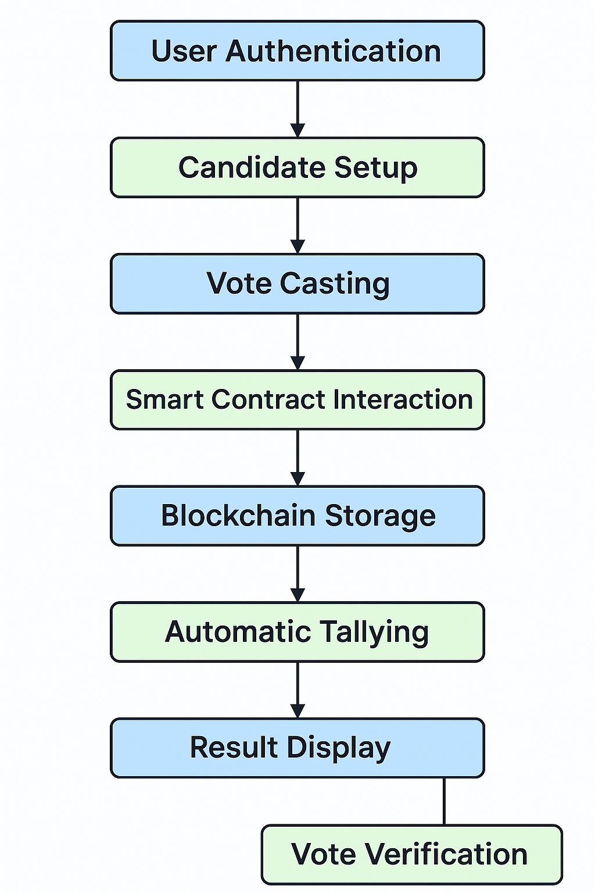
- Voters
  - User-Friendliness: The e-voting system must be easy to use, with an intuitive interface that is accessible to users of all technological literacy levels.
  - Privacy: Voters must have confidence that their vote will remain anonymous and confidential.
  - Authentication Options: Voters should be able to authenticate themselves securely, using methods like government-issued IDs, biometrics (fingerprint or facial recognition), or two-factor authentication (2FA).
  - Multi-Language Support: The system should support multiple languages to cater to diverse populations.
  - Accessibility: The platform should be accessible to people with disabilities, including options for screen readers, text-to-speech, and voice-controlled navigation.
- Election Officials and Administrators
  - Easy Access to Data: Election officials must be able to access real-time voting data, check voter registration status, and manage the voting process.
  - Audit Logs: The system must allow election authorities to access secure, immutable logs to verify election results and perform audits.
  - Security Controls: Administrators must have granular control over user access levels to prevent unauthorized access to sensitive election data.
  - Training and Support: Election officials need adequate training and support to efficiently use the e-voting system during election cycles.
- Auditors and Observers
  - Transparency: Auditors should have easy access to immutable records of voting activity and results to verify the fairness and accuracy of the election.
  - Security and Privacy: While transparency is important, auditors must respect voter privacy and ensure that personal data is not exposed during the auditing process.

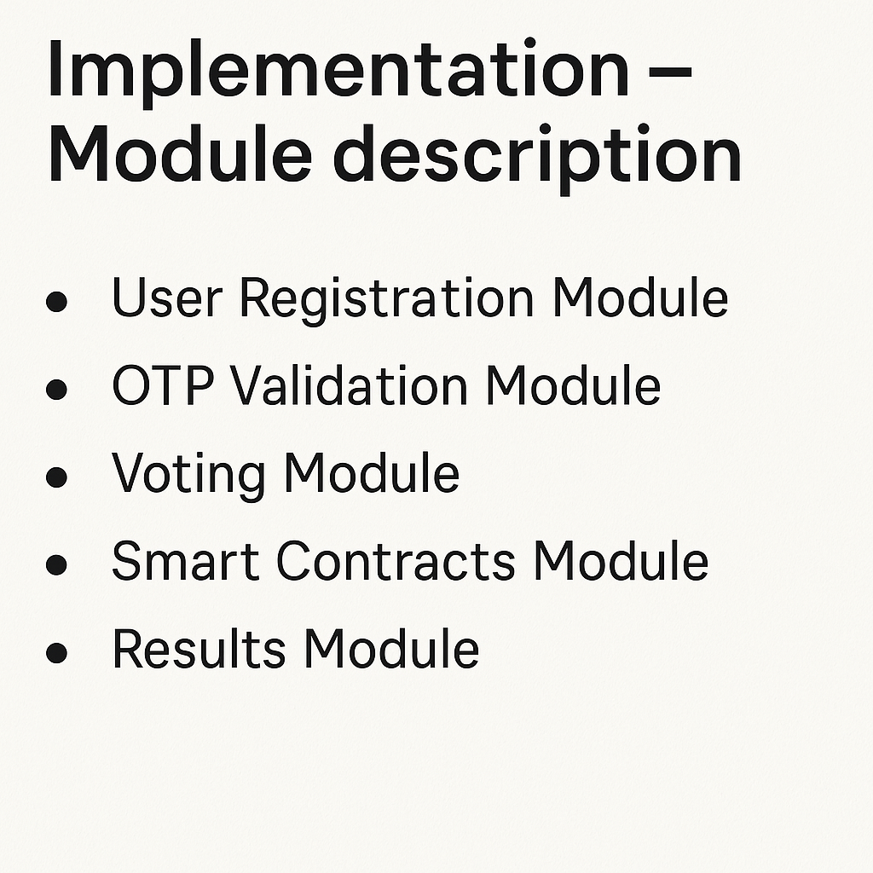

4. System Design
The system design for the proposed blockchain-based e-voting system includes the architecture of the platform as well as the methods and algorithms employed to achieve its goals, such as transparency, security, and integrity. The design incorporates blockchain technology to ensure that all votes are recorded immutably, that voters’ privacy is protected, and that the entire election process remains transparent and verifiable.
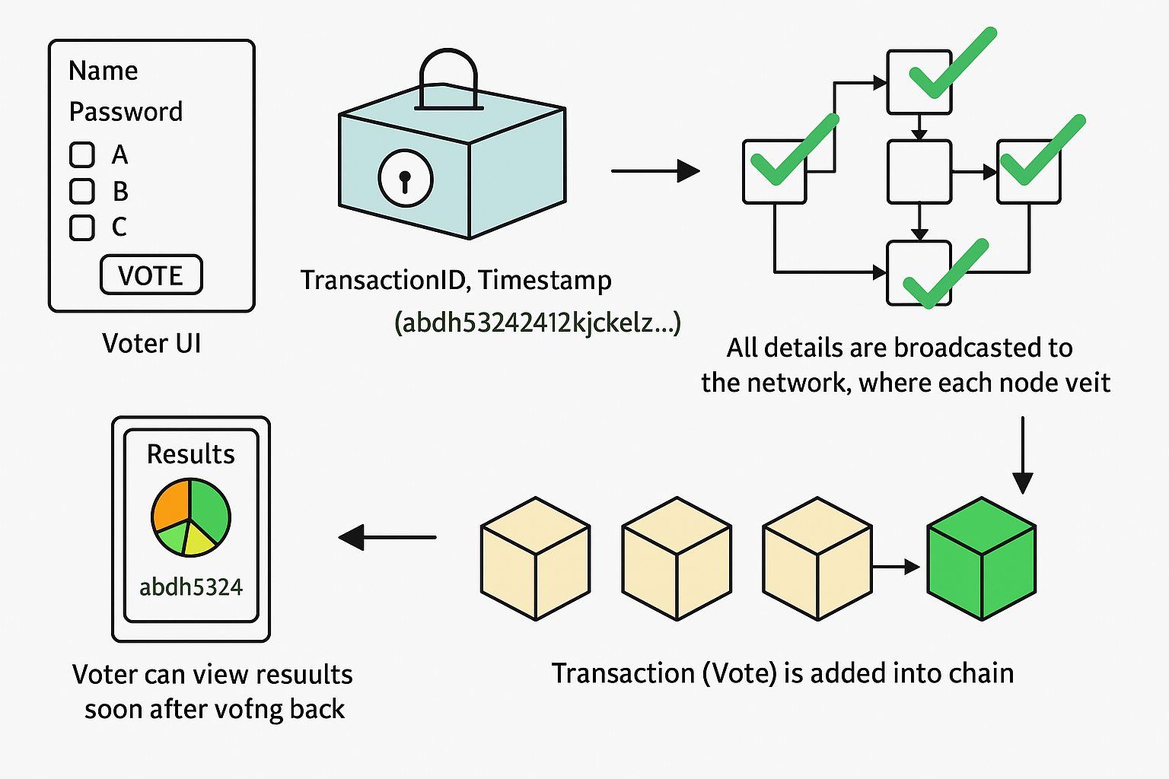

4.1 Proposed System Architecture
The proposed system architecture consists of several interconnected layers: the Client Layer, Application Layer, Blockchain Layer, and Data Storage Layer. Each layer is designed to perform specific tasks, ensuring seamless interaction between all components while ensuring that the e-voting process remains secure and transparent.
1. Client Layer (Voter Interface)
- Voter Interface (Web/Mobile App): Voters interact with the system through a web or mobile application. This interface provides a simple and secure voting experience, where voters can authenticate themselves, view candidates/issues, and cast their vote.
  - Authentication: Voter authentication is performed using biometric methods (e.g., facial recognition, fingerprint scanning), two-factor authentication (2FA), or government-issued ID verification.
  - Voting UI: Once authenticated, voters are presented with a clean, user-friendly voting interface, displaying the candidates/issues they can vote on.
  - Vote Confirmation: After voting, voters receive a unique transaction hash, which they can use to verify that their vote has been successfully cast and recorded.
2. Application Layer (Backend)
- Backend Servers: The backend layer handles all interactions between the user interface (client layer) and the blockchain network. It processes voter requests and coordinates vote submission, encryption, and interaction with the blockchain.
  - Vote Casting: The backend application receives votes from the voter interface, verifies them, and encrypts the vote data before sending it to the blockchain.
  - Smart Contracts: Smart contracts are deployed to the blockchain and ensure that votes are valid, tallied correctly, and processed according to the election rules.
  - Blockchain Interaction: The application interacts with the blockchain through APIs or a middleware layer, ensuring that votes are recorded securely and in a transparent manner.
4.2 Proposed Methods/Algorithms
The blockchain-based e-voting system uses several methods and algorithms to ensure security, transparency, and integrity. Below are the key methods and algorithms used in the system.
1. Authentication and Security Algorithms
- Email-Based OTP for Voter Authentication
To ensure that only eligible and registered voters can access the e-voting system, an OTP-based authentication system using email is implemented.
OTP Generation & Security:
- HMAC-based OTP (HOTP) or Time-based OTP (TOTP) using algorithms like SHA-256 or SHA-512.
- Ensures OTPs are unpredictable and expire quickly, reducing the risk of brute-force attacks.

- Public Key Infrastructure (PKI): The system uses a PKI framework to encrypt and securely store sensitive data such as voter identity and vote transactions. Public/private key pairs are used to encrypt votes before they are sent to the blockchain.
  - RSA Encryption: A widely used asymmetric encryption algorithm, RSA is used to securely transmit vote data and prevent unauthorized access.
  - AES (Advanced Encryption Standard): AES is used for symmetric encryption to protect the confidentiality of the vote itself, ensuring that votes are encrypted end-to-end.
2. Vote Casting and Recording Algorithm
- Vote Data Integrity: The data integrity of the vote is guaranteed using a hashing algorithm. When a vote is cast, the vote data is hashed using a cryptographic hash function (e.g., SHA-256), ensuring that it cannot be modified once recorded.

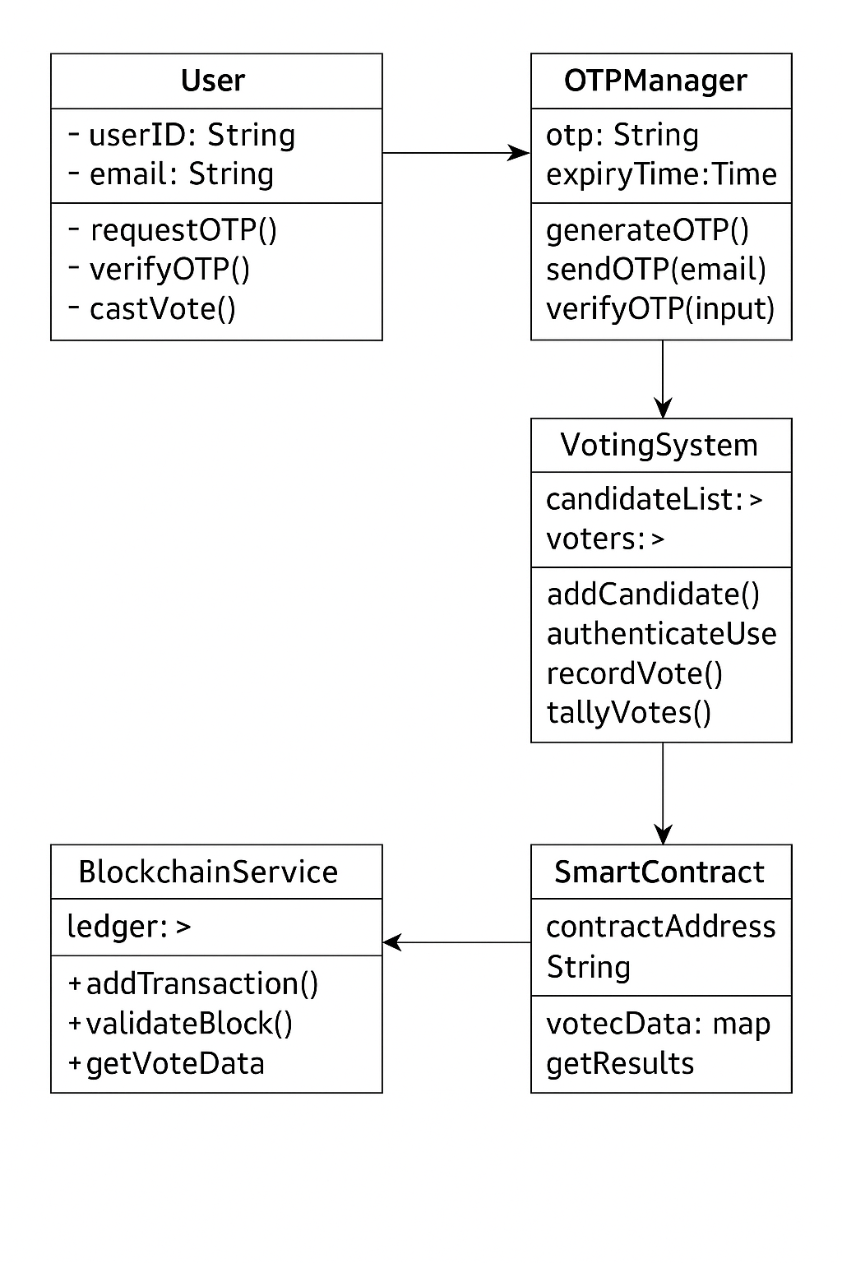
CLASS DIAGRAM:

5. Implementation
The implementation phase of the blockchain-based e-voting system involves creating and deploying the system’s components, ensuring that it functions as intended across various layers. This includes the development of the front-end interface (for voters and election officials), the integration of blockchain for vote recording, tallying, and result generation, and the backend logic that supports these operations.
Here, we'll provide an overview of the front-end interface (screenshots of the front page), explain the process for result generation, and outline how the system functions end-to-end.

5.1 Front Page Screenshot
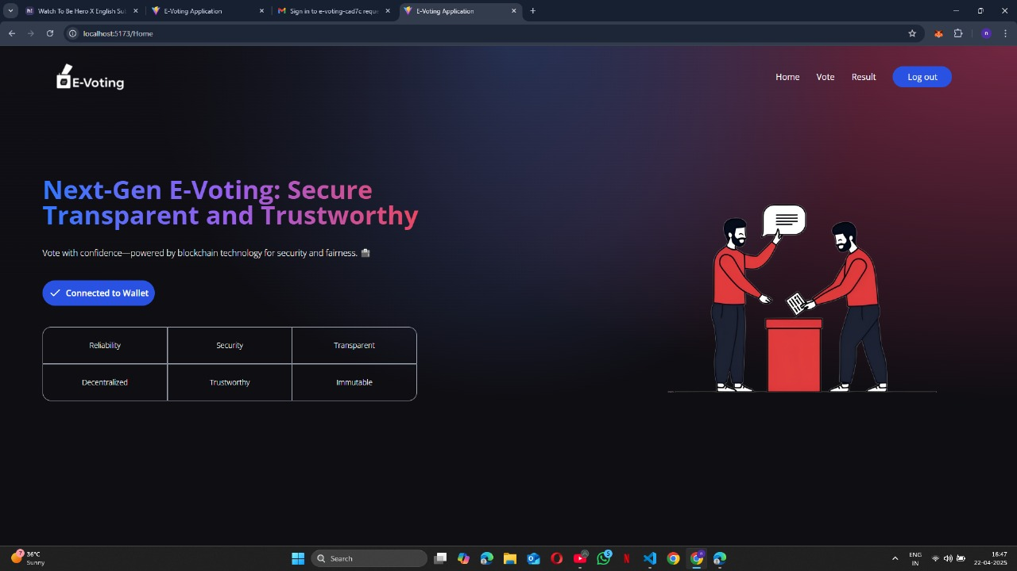

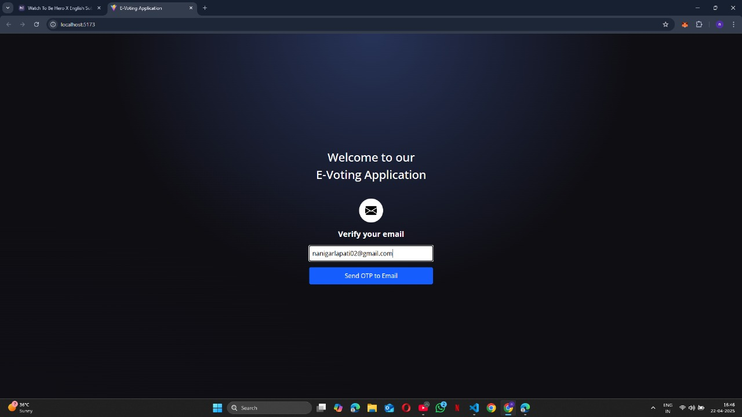
5.2 Result Generation and Result Page
Result Page Interface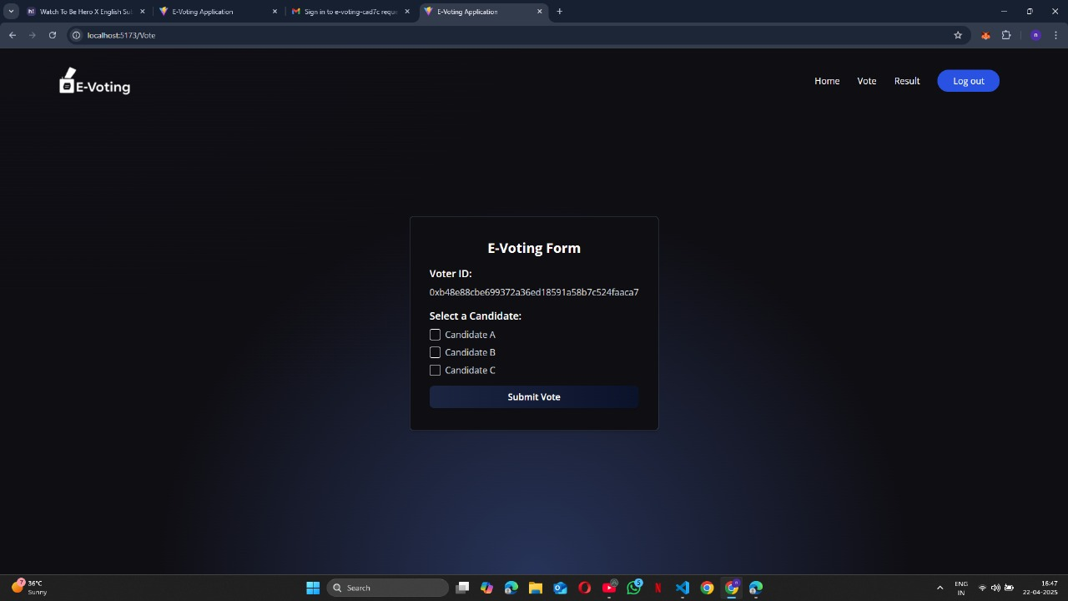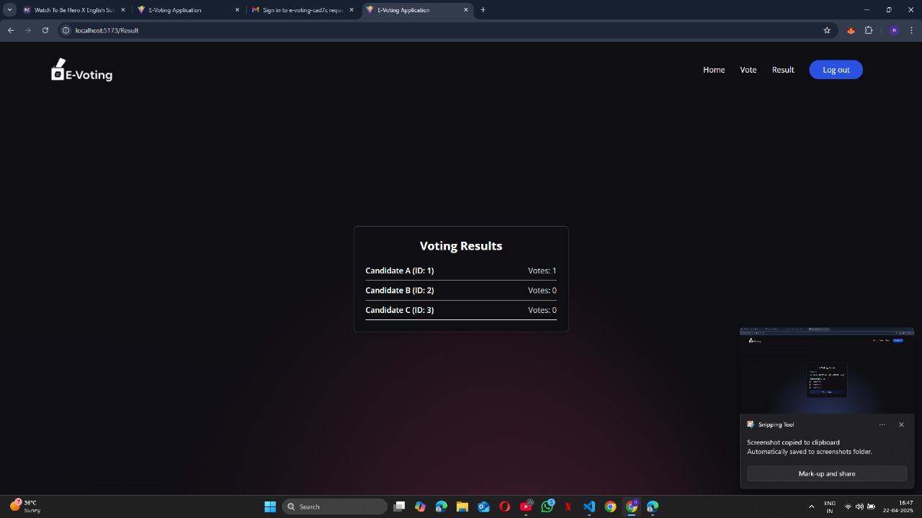

6 .Conclusion
The proposed blockchain-based e-voting system represents a significant advancement in the way elections are conducted. By integrating blockchain technology, we ensure that the voting process is secure, transparent, and tamper-resistant. The immutability of blockchain guarantees that once votes are cast, they cannot be altered, providing a high level of trust in the election process.
The system effectively addresses many of the challenges associated with traditional voting systems, including voter fraud, vote tampering, and lack of transparency. With features like biometric authentication, encryption, and smart contract-based vote tallying, the platform offers enhanced security and integrity. Additionally, the decentralized nature of the blockchain ensures that no single entity can control or manipulate the election results, making the election process truly democratic and transparent.
Moreover, by leveraging the audit capabilities of the blockchain, voters, election officials, and auditors can independently verify the results, adding an extra layer of accountability and trust. The real-time tallying of votes and the automated result generation minimize the need for manual counting, reducing human error and potential delays in result announcement.
In conclusion, the blockchain-based e-voting system offers an efficient, secure, and transparent solution for modern elections, ensuring a more trustworthy democratic process.

6.1 Future Scope
While the current implementation of the blockchain-based e-voting system demonstrates a promising future for secure digital voting, there are several areas where the system can be enhanced and expanded in the future:
- Scalability and Performance Optimization:
  - As the number of voters and transactions increases, the scalability of the blockchain platform will become critical. Future work can focus on optimizing the performance of the blockchain to handle large-scale elections with millions of voters.
  - Integration with high-performance blockchain platforms or the development of more efficient consensus mechanisms (such as Proof of Authority or Delegated Proof of Stake) could help address performance concerns.
- Improved User Experience:
  - Further improving the user interface (UI) and user experience (UX) for voters is crucial to ensure ease of use, especially for individuals who may not be technologically savvy. The system can be designed to support multiple languages and more intuitive navigation.
  - Enhancing mobile apps for accessibility in remote areas or regions with limited access to traditional voting systems would improve voter participation.

REFERENCES

Books:
- Mastering Blockchain: Unlocking the Power of Cryptocurrencies, Smart Contracts, and Decentralized Applications
  - Author: Imran Bashir
  - Publisher: Packt Publishing
  - Year: 2021
  - Description: This book provides comprehensive coverage of blockchain technology, including its applications in cryptocurrencies, smart contracts, and decentralized applications (DApps). It includes examples of how blockchain can be utilized for secure and transparent systems, such as e-voting.
- Blockchain Basics: A Non-Technical Introduction in 25 Steps
  - Author: Daniel Drescher
  - Publisher: Apress
  - Year: 2017
  - Description: An introductory book for non-technical readers to understand blockchain. It provides the basic concepts and lays the foundation for understanding blockchain's application in e-voting.
- Blockchain Applications: A Hands-On Approach
  - Authors: Arshdeep Bahga, Vijay Madisetti
  - Publisher: VPT
  - Year: 2019
  - Description: This book covers the theory and practical applications of blockchain, including its potential in e-voting systems. It includes hands-on examples and use cases for blockchain technology.
Articles:
- Nakamoto, S. (2008).
Bitcoin: A Peer-to-Peer Electronic Cash System
  - Link: Bitcoin White Paper
  - Summary: This is the original white paper that introduced Bitcoin and, by extension, blockchain technology. It is foundational to understanding the principles of decentralization, security, and consensus mechanisms that can be applied in blockchain-based e-voting systems.
- Zohar, S. (2015).
Bitcoin: A Comprehensive Review of the Blockchain Technology
  - Journal: International Journal of Computer Science and Information Security, 13(6), 1-12.
  - Link: IJCSIS Journal
  - Summary: A detailed review of blockchain technology, covering its core principles, cryptography, and applications, with implications for sectors like e-voting.
WEBSITES
• Ethereum
- Official site for the Ethereum blockchain, which is widely used in decentralized applications, including e-voting systems.
• IBM Blockchain
- IBM’s blockchain solutions offer extensive resources on how blockchain can be used for secure, transparent applications like e-voting.
• Hyperledger
- Hyperledger is an open-source collaborative effort to build blockchain frameworks. Their resources include solutions for industries like e-voting.
• CoinDesk
- Leading blockchain news site, offering articles on the latest blockchain developments and how they impact sectors like government and elections.

APPENDIX:
Lock.js
const {
time,
loadFixture,
} = require("@nomicfoundation/hardhat-toolbox/network-helpers");
const { anyValue } = require("@nomicfoundation/hardhat-chai-matchers/withArgs");
const { expect } = require("chai");

describe("Lock", function () {
// We define a fixture to reuse the same setup in every test.
// We use loadFixture to run this setup once, snapshot that state,
// and reset Hardhat Network to that snapshot in every test.
async function deployOneYearLockFixture() {
const ONE_YEAR_IN_SECS = 365 * 24 * 60 * 60;
const ONE_GWEI = 1_000_000_000;

const lockedAmount = ONE_GWEI;
const unlockTime = (await time.latest()) + ONE_YEAR_IN_SECS;

// Contracts are deployed using the first signer/account by default
const [owner, otherAccount] = await ethers.getSigners();

const Lock = await ethers.getContractFactory("Lock");
const lock = await Lock.deploy(unlockTime, { value: lockedAmount });

return { lock, unlockTime, lockedAmount, owner, otherAccount };
}
it("Should fail if the unlockTime is not in the future", async function () {
// We don't use the fixture here because we want a different deployment
const latestTime = await time.latest();
const Lock = await ethers.getContractFactory("Lock");
await expect(Lock.deploy(latestTime, { value: 1 })).to.be.revertedWith(
"Unlock time should be in the future"
);
});
});

describe("Withdrawals", function () {
describe("Validations", function () {
it("Should revert with the right error if called too soon", async function () {
const { lock } = await loadFixture(deployOneYearLockFixture);

await expect(lock.withdraw()).to.be.revertedWith(
"You can't withdraw yet"
);
});

it("Should revert with the right error if called from another account", async function () {
const { lock, unlockTime, otherAccount } = await loadFixture(
deployOneYearLockFixture
);

// We can increase the time in Hardhat Network
await time.increaseTo(unlockTime);

// We use lock.connect() to send a transaction from another account
await expect(lock.connect(otherAccount).withdraw()).to.be.revertedWith(
"You aren't the owner"
);
});

it("Shouldn't fail if the unlockTime has arrived and the owner calls it", async function () {
const { lock, unlockTime } = await loadFixture(
deployOneYearLockFixture
);

// Transactions are sent using the first signer by default
await time.increaseTo(unlockTime);

await expect(lock.withdraw()).not.to.be.reverted;
});
});

describe("Events", function () {
it("Should emit an event on withdrawals", async function () {
const { lock, unlockTime, lockedAmount } = await loadFixture(
deployOneYearLockFixture
);

await time.increaseTo(unlockTime);

await expect(lock.withdraw())
.to.emit(lock, "Withdrawal")

});
Deploy.js:
const { ethers } = require("hardhat");

async function main() {
const Voting = await ethers.getContractFactory("Voting"); // Ensure this matches your contract name
const voting = await Voting.deploy(['Candidate A', 'Candidate B', 'Candidate C']);
await voting.waitForDeployment();

console.log("Voting contract deployed to:", await voting.getAddress());
}

main().catch((error) => {
console.error(error);
process.exitCode = 1;
});

Voting.sol:
// SPDX-License-Identifier: MIT
pragma solidity ^0.8.0;

contract Voting {
struct Candidate {
uint256 id;
string name;
uint256 voteCount;
}

mapping(uint256 => Candidate) public candidates;

mapping(address => bool) public voters;

uint256 public candidatesCount;

event Voted(uint256 indexed candidateId);

constructor(string[] memory candidateNames) {
for (uint256 i = 0; i < candidateNames.length; i++) {
addCandidate(candidateNames[i]);
}
}

function addCandidate(string memory name) public {
candidatesCount++;
candidates[candidatesCount] = Candidate(candidatesCount, name, 0);
}

function vote(uint256 candidateId) public {
require(!voters[msg.sender], "You have already voted.");

require(candidateId > 0 && candidateId <= candidatesCount, "Invalid candidate ID.");

candidates[candidateId].voteCount++;
voters[msg.sender] = true;

emit Voted(candidateId);
}

function getVotes(uint256 candidateId) public view returns (uint256) {
require(candidateId > 0 && candidateId <= candidatesCount, "Invalid candidate ID.");
return candidates[candidateId].voteCount;
}

function hasvoted(address voter) public view returns (bool) {
return voters[voter];
}

function getWinner() public view returns (uint256) {
uint256 winningVoteCount = 0;
uint256 winningCandidateId = 0;

for (uint256 i = 1; i <= candidatesCount; i++) {
if (candidates[i].voteCount > winningVoteCount) {
winningVoteCount = candidates[i].voteCount;
winningCandidateId = i;
}
}

return winningCandidateId;
}
}

